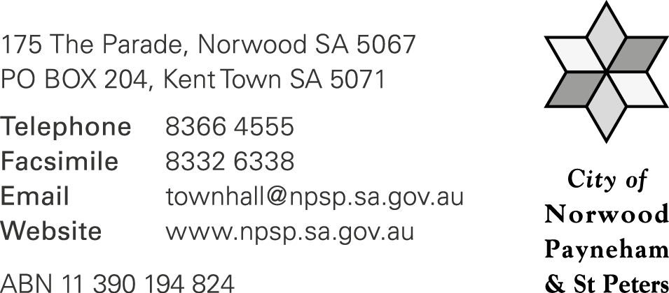
TERMS & CONDITIONS

TAG & WIN COMPETITION 2021 (“COMPETITION”)

General
- The Competition is being conducted by The City of Norwood Payneham & St Peters, 175 The Parade, Norwood SA 5067 (ABN 11390194824) (“Promoter”).

- Entry into the Competition is deemed as acceptance of these Terms and Conditions.

The Competition commences at 9.00am on Monday 16 August 2021 and closes at 11.59pm on Monday 23 August 2021 (“Closing Date and Time”). All Competition entries must be received by the Promoter prior to the Closing Date and Time. Late entries will not be admitted to the competition under any circumstances.

Eligibility

- The Competition is open to all South Australian residents 18 years of age or older excluding elected members and officers or employees of the Promoter and their immediate families (being any person within the definition of ‘relative’ in the Local Government Act 1999).

Entering

- To enter the Competition, an Entrant must post a story on Instagram with a photo or video of a Participating Business and must include the tag @paradenorwood before the Closing Date and Time (‘the Entrant’). Entrants must have their Instagram account on public so that the Promoter is notified of the entry.

- A Participating Business means any retailer, café, food outlet and/or service provider within The Norwood Parade Precinct between Portrush Road and Fullarton Road. For a full list of participating retailers, cafés or food outlets visit: www.theparadenorwood.com

- Each Entrant may only submit one (1) entry. There is no entry fee and no purchase is necessary to enter this competition.

- The Promoter reserves the right to verify the validity of all entries and reserves the right to disqualify any Entrant for tampering with the entry process, including but not limited to the utilisation of techniques designed to make multiple entries with a single purchase or for submitting an entry or otherwise acting in any manner which is not in accordance with these Competition Terms and Conditions.

Prize

- The Prize means one (1) voucher to the value of thirty dollars ($30.00) to Participating Business of the Winners’ choice.

- The Prize cannot be transferred, exchanged or redeemed for cash. The Prize can be limited to specific ranges by a Participating Business at any time without notice. The Promoter and the Participating Business reserves the right to substitute the Prize in whole or part with another Prize of equal or greater value.

Draw

- The Prize will be drawn at random at 12.00pm on Wednesday 25 August 2021 at the City of Norwood Payneham & St Peters, 175 The Parade, Norwood SA 5067.

- Twenty (20) Entrants shall receive the Prize.

- The Winners will be notified by direct message on Instagram within 48 hours of the Closing Date and Time. The Winner must respond to the direct message and advise the Council of their choice of Participating Business for the Prize. If a Winner cannot be contacted or does not claim the prize within seven (7) days of notification, the Winner forfeits the Prize and the Council reserves the right to draw a new Winner.

- The Winners will be announced on the Council’s ‘The Parade’ Instagram profile and www.theparadenorwood.com on Thursday 26 August 2021.

General
- As a condition of entering this Competition, the Entrant agrees to the use of their name, image and Entry by the Promoter for publicity and promotional purposes in connection with this Competition, including (without limitation) sharing their Entry on the Council’s ‘The Parade’ Instagram profile.

- This promotion is in no way sponsored, endorsed or administered by, or associated with, Facebook, Instagram or any other Social Network. You are providing your information to [the Promoter and not to any other party.

- If for any reason this Competition is not capable of running as planned, the Promoter reserves the right in its sole discretion to cancel, terminate, modify or suspend the Competition without any liability to any Entrant.

